Spring Boot Project High-level Architecture Diagram:
The high-level architecture diagram depicts the flow of data and interactions within the Spring Boot application. It illustrates how frontend UI/Postman communicates with the Spring Boot API, which further coordinates with the service layer and Spring Data JPA to perform CRUD operations on the MySQL database.
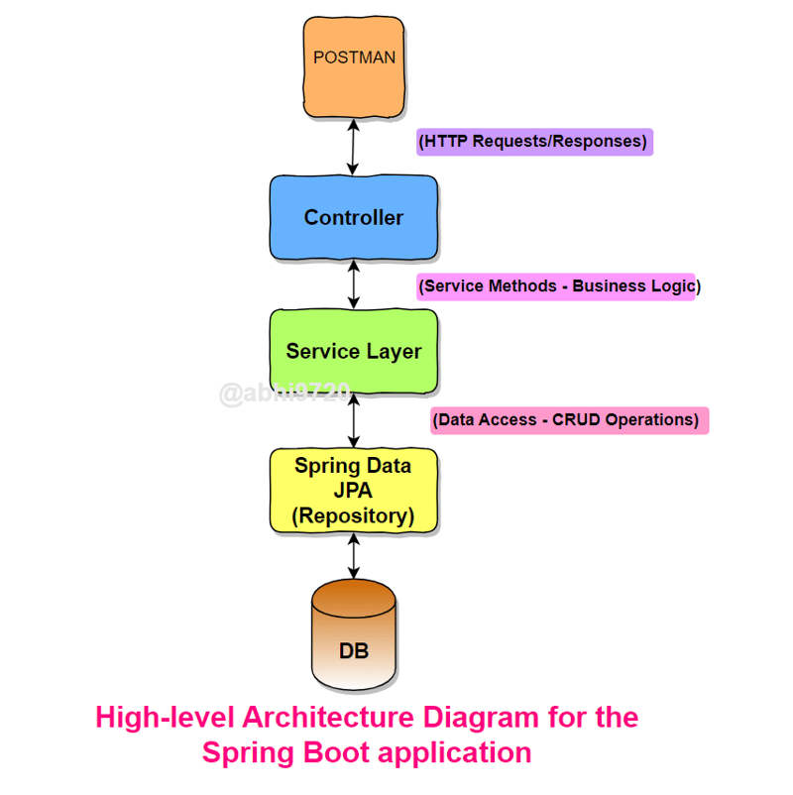

Step 1: Setting up the Project
Let's begin by creating a new Spring Boot project:
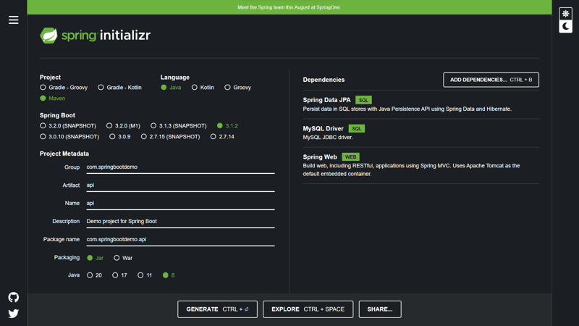
- Go to Spring Initializr (https://start.spring.io/) to create a new Spring Boot project.
- Add the required dependencies:
  - Spring Web: Provides the necessary components for building web applications.
  - Spring Data JPA: Simplifies database access using JPA (Java Persistence API).
  - MySQL Driver: Allows Spring Boot to communicate with the MySQL database.
- Generate the project and import it into your IDE.

Step 2: Database Configuration
Now, let's configure the database to store our data. In this example, we will use MySQL:
- Install MySQL on your local machine if you haven't already. You can download it from the official website: https://dev.mysql.com/downloads/installer/.
- Create a new database nec.
- Create database nec;
- Use nec;

Step 3: Creating the Entity
In Spring Boot, an entity represents a table in the database. Let's create an entity class representing our "users" table:

// User.java
import javax.persistence.*;

@Entity
@Table(name = "employee")
public class Employee {

private String password;

private String name;
@Id
private String email;
private String address;

// Getters and setters
}

Step 4: Defining Application Properties
The src/main/resources/application.properties
# Database Configuration
spring.datasource.url=jdbc:mysql://localhost:3306/nec
spring.datasource.username=root
spring.datasource.password=rajesh
# Hibernate Configuration
spring.jpa.hibernate.ddl-auto=update
spring.jpa.properties.hibernate.dialect=org.hibernate.dialect.MySQL8Dialect

server.port=10000

Step 5: Creating the Repository
Src/main/java/com/banking/dao/UserRepository.java
// UserRepository.java
import org.springframework.data.jpa.repository.JpaRepository;

@Repository
public interface UserRepository extends JpaRepository<Employee, Long> {

}

Step 6: Implementing the Service Layer
The service layer contains the business logic and coordinates with the repository to perform database operations. Let's create the service class for our API:

// UserService.java
import org.springframework.beans.factory.annotation.Autowired;
import org.springframework.stereotype.Service;

import java.util.List;

@Service
public class UserService {

@Autowired
private UserRepository userRepository;

public User createUser(User user) {
return userRepository.save(user);
}

public List<User> getAllUsers() {
return userRepository.findAll();
}

public User getUserById(String id) {
return userRepository.findById(id).orElse(null);
}

public User updateUser(String id, Employee user) {
user.setId(id);
return userRepository.save(user);
}

public void deleteUser(String id) {
userRepository.deleteById(id);
}
}

Step 7: Creating the Controller
The controller handles HTTP requests and invokes the service methods. It remains unchanged from the previous blog:

// UserController.java
import org.springframework.beans.factory.annotation.Autowired;
import org.springframework.web.bind.annotation.*;

import java.util.List;

@RestController
@RequestMapping("/api/v1/employees")
public class UserController {

@Autowired
private UserService userService;

@PostMapping
public User createUser(@RequestBody User user) {
return userService.createUser(user);
}

@GetMapping
public List<User> getAllUsers() {
return userService.getAllUsers();
}

@GetMapping("/{id}")
public User getUserById(@PathVariable Long id) {
return userService.getUserById(id);
}

@PutMapping("/{id}")
public User updateUser(@PathVariable Long id, @RequestBody User user) {
return userService.updateUser(id, user);
}

@DeleteMapping("/{id}")
public void deleteUser(@PathVariable Long id) {
userService.deleteUser(id);
}
}

Step 8: Running the Application
- Right click on main file and run as java aaplication

Step 9: Testing the API Endpoints
Testing using postman

